Mahajana Education Society ®
Education to Excel
SBRR Mahajana First Grade College (Autonomous)
Jayalakshmipuram, Mysuru – 570 012
Affiliated to the University of Mysore
Re-accredited by NAAC with ‘A’ Grade, College with Potential for Excellence

Date: 12stFebruary 2020
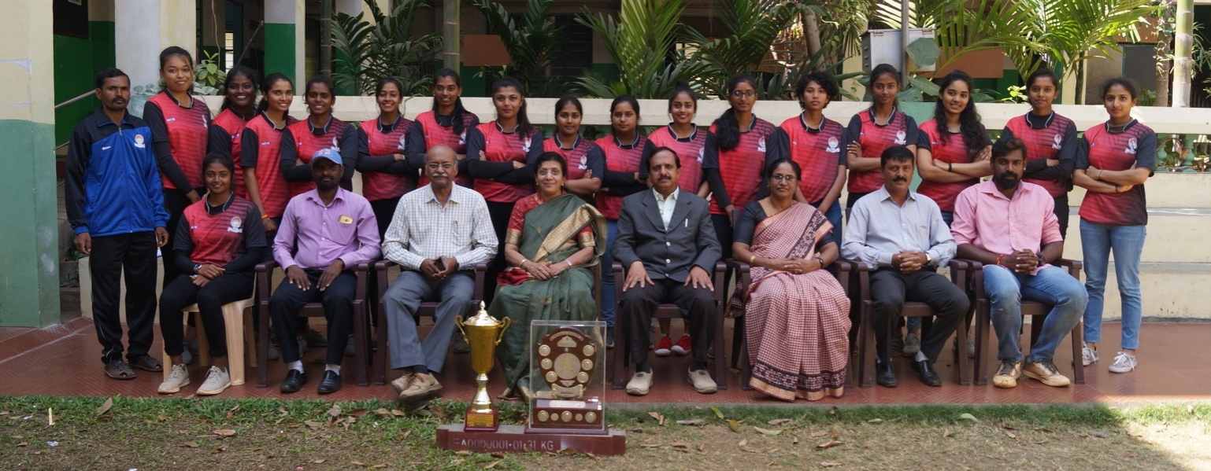
SBRR Mahajana First Grade College Won the University
Inter-collegiate & Inter-ZonalWomen’s Softball Tournament
SBRR Mahajana First Grade College won the Gold Medal and Winners’ Trophy in Inter-collegiate and Inter Zonal Women’s Softball Tournament held at Bharathi College, Bharathi Nagar, K. M. Doddi, Mandya which was held from 4thFebruary 2020 to 6th February 2020. (From Left to Right sitting) Captain AnvithaRao, Sri. Madhusudhana P.S., Physical Director, Dr. Ramesh S.R., Chief Executive Officer, Mrs. VijayalakshmiMuralidhar, Secretary, Mahajana Education Trust, Dr. Venkataramu, Principal, Mrs. Jayakumari, Vice Principal, Dr. Bhaskar H.N., Physical Director, Mr. Karthik.
(Standing from Left to Right ) Mr. Somashekhar, Sports Assistant, students participants Neha, Agness, Bhavani, Nikhita, Archana, Chaya, MadhuMuttamma, Tejaswini, Supreetha, Nizi, KavanaChoudamma, Aishwarya, Bhavana, Vyshanavi, Priyanka and Sheetalare seen in the picture.
News in Brief:
Mysore, Feb. 12: A highly exciting and entertaining match between SBRR Mahajana First Grade College and Post-Graduation and Sports Council, Manasagangothri, Mysore. The Women’s Softball team of SBRR Mahajana First Grade College are the Winners of Mysore University Inter-collegiate and Inter-Zonal Women’s Softball Tournament held at Bharathi College, Bharathi Nagar, K. M. Doddi, Mandya which was held on 4thFebruary 2020 to 6th February 2020 and Secured First Place. The tournament was organized and held at Bharathi College, Bharathi Nagar, K. M. Doddi, Mandya from 4thFebruary 2020 to 6th February 2020.
Principal

